PARSEC AIRFOIL OPTIMIZATION

Datasets: <https://m-selig.ae.illinois.edu/ads/coord_database.html>

Datasets: <http://www.airfoiltools.com/>

Some NASA Applications - <https://www1.grc.nasa.gov/beginners-guide-to-aeronautics/foilsimstudent/>

INTRODUCTION

Types of airfoil parameterization methods

NACA

CST

PARSEC

..

Designing an efficient airfoil for aerodynamic applications is a complex challenge in the field of aerodynamic engineering, intending to achieve an optimal lift-to-drag ratio.

success of airfoil design hinges on the effective reduction of drag force under specific conditions, while simultaneously attaining the desired lift without encountering significant flow separation, such as boundary layer shedding. Furthermore, the design must adhere to lifting force limitations and meet.

Optimizer -

Aerodynamic characteristics of aircraft would be better with **increasing angle of attack** (AOA) However, a large angle of attack causes stall. critic angle of attack (AOA) is determined as 15°. **lift-to-drag ratio Cl/Cd** is calculated to compare various scenarios. Also, the **Cl value of airfoils is considered because Cl is an important factor that affects lifting force.** The aerodynamic team analyzed selected airfoils between 0° and 15° AOA and compared them according to Cl/Cd and Cl-α values.

These airfoils were analyzed using **XFLR-5. XFLR5** is an analysis tool for airfoils, planes, and wings that operate at low Reynolds Numbers. Wing design and accordingly **wing analysis have been conducted using the Lifting Line Theory, the Vortex Lattice Method, and the 3D Panel Method**. The increase in lift occurs because the up-wash field effectively rotates the lift vector forward, reducing the induced drag. The airfoil that has the best result is the **Cl (lift coefficient)-Cd (drag coefficient) graph** and it would be the best choice for designed aircraft because the Cl/Cd ratio is an important factor in take-off  Aircraft which has an airfoil that provides the highest Cl value when Cd value is low, will have an easy takeoff. The airfoil that has the best graph result is MH 114. When analyzing other graphs it can be seen that MH 114 has the best results. While determining AOA, Cl-α and Cl/Cd-α graphs are examined. The best AOA is found at 4° but if the Cl-α graph is considered, AOA can be chosen between 4° and 14°. As a result of comparisons MH 114 was selected as the airfoil and AOA (angle of attack) was selected as 5°. Lift force generally depends on pressure distribution along the airfoil shape, while drag force depends on both pressure and friction distribution.

Lift force generally depends on pressure distribution along the airfoil shape, while drag force depends on both pressure and friction distribution.

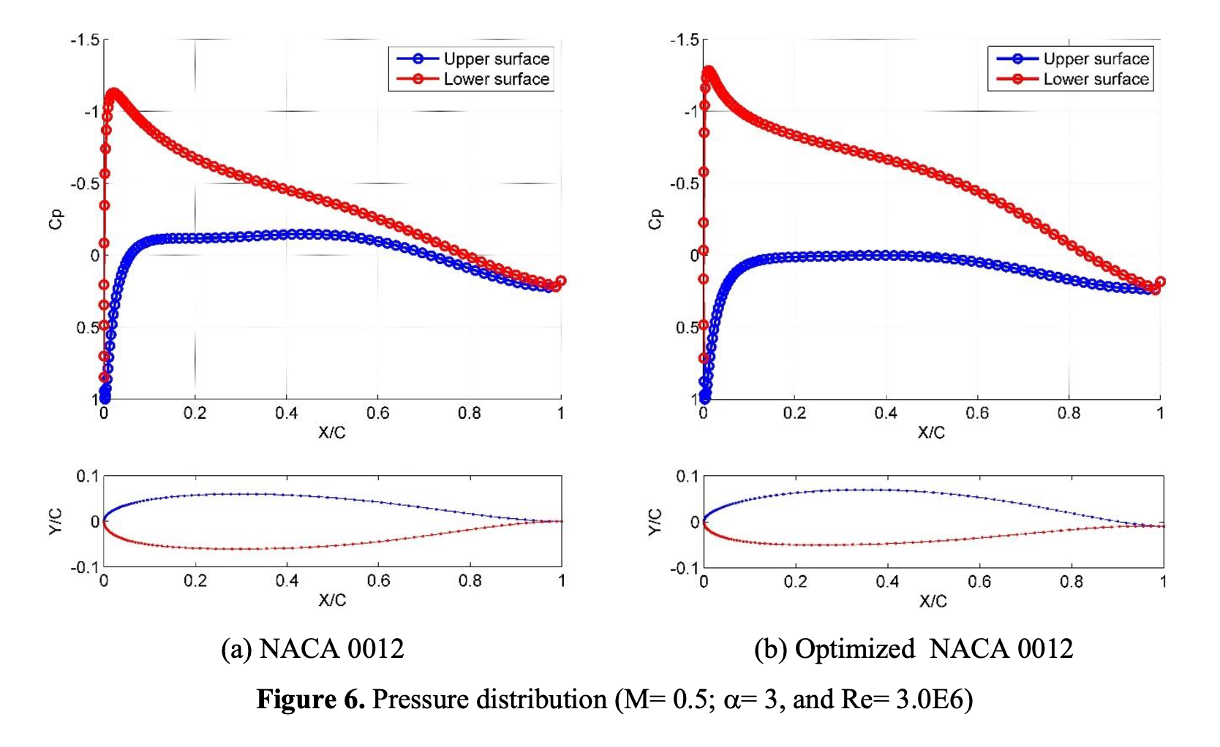

shows pressure distribution comparison along the airfoil surface. The pressure distributions are plotted under the same operating conditions which are M= 0.3, α= 3°, and Re= 3.0E6.

the pressure on lower surface reaches the lowest value relatively close to the leading edge. This means that pressure gradient extend only no more than 5% of the cord length. pressure distribution along upper surface starts with stagnation condition. Cp= 1 occurs at leading edge, X/C= 0, for both airfoil design. Figure 6 also shows difference between the upper and lower surface pressure. It is negative along the entire cord, indicating that all segments of the cord are constributing on the lift force. On the lower optimized surface, the pressure distribution is almost flat. Pressure difference of the optimized airfoil shape is larger than pressure distribution of basic NACA 0012, indicating also better in lift coefficient compared with basic NACA 0012.

**

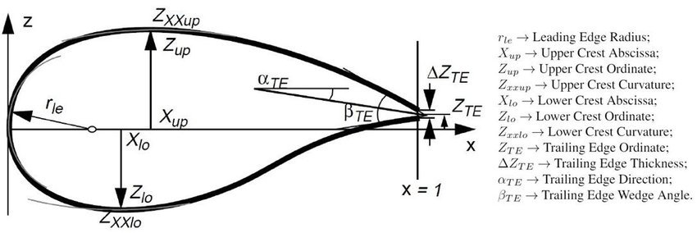

|  |  |  |
| --- | --- | --- |
| A | Reference area | Chord * cos(AOA) * span(wing length) |
| AOA | Angle of attack | -100  - +100 |
| L | Lift force |  |
| CL/CD (-15 +15) |  | MAXIMIZE |
|  |  |  |
|  |  |  |

Meeting 2 logs

|  |
| --- |
| Discussion –   1. Get ideal conditions to optimize the cl/cd. – dropping the ML model (keeping some parameters constant and running simulations) 2. Finding the optimal value threshold value from a range of something (based on wind what is the maximum point of the parameter which might break the wing) (during air density range, where is the point which drops the aerodynamic performance – butterfly effect ). 3. The parameter values that are used to calculate the lift and drag coefficient may be all covered by Reynold and the Mach number. can we derive an equation to get the fitness? 4. Up sample the dataset- Cross-validation, grid search   We only have a very small part of the entire population. If building a model only uses that small part of the population. We might get 90% accuracy. But what if the calculated x-y coordinates are taken from the outside? The predicted output will be wrong because the model has not seen that type of data before.  Current problem - How to make the ANN model more generalized?  Suggestions :   1. Interpolate the resultant values of neighboring data points to get new data points in between neighbors.   **“Take it or leave it.”** |

Checklist:

|  |
| --- |
| ***Airfoil builder – Ak*** |
| ***Deploy – Malitha*** |
| ***GUI*** – GUI ideas lakindu   |
| ***Data analysis – lakindu.***  **Check list.**   1. **Validation dataset 50 web scraping** 2. ***Make the proper model dataset AOA must be in the same column.*** 3. ***Matrix scenes need to be re checked.***   A large volume of experimental airfoil data was recorded over the years by the National Advisory Committee for Aeronautics (NACA), which later on became a part of National Aeronautics and Space Administration (NASA) in 1958. The airfoils were characterized into multiple series, for example: NACA 4- and 5-digit series. These two series are considered in this work.  NACA 4-digit series is defined by the following profile   * First digit describes the maximum camber as percentage of the chord. * Second digit describes the distance of maximum camber from the airfoil leading edge in tenths of the chord. * Last two digits describe maximum thickness of the airfoil in form of percentage of the chord.   The NACA five-digit series describes more complex airfoil shapes. Its format is LPSTT where:   * L: a single digit representing the theoretical optimal lift coefficient at ideal angle of attack. * P: a single digit for the x-coordinate of the point of maximum camber. * S: a single digit indicating whether the camber is simple (S=0)orreflex(S=1). * TT: the maximum thickness in percent of the chord, as in a four-digit NACA airfoil code.   **Mach number approximated range** - (0.1 : 9.6)  **Reynold number approximated range** – (100,000 – 100,000,000)  **NASA Technical Report Server Dataset Problems** :  Reynold number – (100000, 200000, 300000, 400000, 500000)  Mach number – (0.1, 0.2, 0.3)   * Current dataset includes 5,10,15 points plot and see if it is same airfoil. * Cluster all airfoil shapes and see how the behavior of the cl and cd changes is according to Reynold and Mach number. * It can overfit. * Vanishing gradient problem * Both the Mach number and Reynold number ranges dataset does not cover wide range of commonly used numbers. * ANN model would be less likely to learn Reynold numbers which is in the middle ex: 105000.  |  |  |  |  |  |  |  |  |  |  |  |  |  |  |  |  |  |  |  | | --- | --- | --- | --- | --- | --- | --- | --- | --- | --- | --- | --- | --- | --- | --- | --- | --- | --- | --- | |  |  |  | 100k | 105k |  | 200k |  | 209k | 300k | 301k |  | 400k |  |  | 500k | 700k |  | 1M |   Predicted data, real data.  Comparison dataset  Airfoil coordinate real cl, cd, cm predicted cl, cd, cm.   * There can be multiple airfoils which may identified as two different airfoils yet has a very small geometric difference ex: y values like (0.5123 – 0.5125 : e - 4). If data like this exist, having the possibility of data leakage from training data to test data resulting a invalid high accuracy.     matrix =[]  for 500:i  for 500:j  sum = 0  for columns y  sum = sum +abs(i[y] -j[y])  matrix[i][j] = sum  **NACA4Digit_Dataset05Point.csv** –  Number of records – 171432  Number of airfoils -  Independent variable – yU_1, yU_2, yU_3, yU_4, yU_5, yL_1, yL_2, yL_3, yL_4, yL_5, RaynoldNumber, MachNumber, alpha  Dependent variables – cl, cd, cm  Reynold number – (100000, 200000, 300000, 400000, 500000)  Mach number – (0.1, 0.2, 0.3)  Angle of attack – (-10,-9,-8,-7,-6,-5,-4,-3,-2,-1,0,1,2,3,4,5,6,7,8,9,10) DEGREES  **NACA4Digit_Dataset10Point.csv** –  Number of records – 171432  Number of airfoils -  Independent variable – yU_1, yU_2, yU_3, yU_4, yU_5, yU_6, yU_7, yU_8, yU_9, yU_10, yL_1, yL_2, yL_3, yL_4, yL_5, yL_6, yL_7, yL_8, yL_9, yL_10, RaynoldNumber, MachNumber, alpha  Dependent variables – cl, cd, cm  Reynold number – (100000, 200000, 300000, 400000, 500000)  Mach number – (0.1, 0.2, 0.3)  Angle of attack – (-10,-9,-8,-7,-6,-5,-4,-3,-2,-1,0,1,2,3,4,5,6,7,8,9,10) DEGREES  **NACA4Digit_Dataset15Point.csv** –  Number of records – 171432  Number of airfoils -  Independent variable – yU_1, yU_2, yU_3, yU_4, yU_5, yU_6, yU_7, yU_8, yU_9, yU_10, yU_11, yU_12, yU_13, yU_14, yU_15, yL_1, yL_2, yL_3, yL_4, yL_5, yL_6, yL_7, yL_8, yL_9, yL_10, yL_11, yL_12, yL_13, yL_14, yL_15 RaynoldNumber, MachNumber, alpha  Dependent variables – cl, cd, cm  Reynold number – (100000, 200000, 300000, 400000, 500000)  Mach number – (0.1, 0.2, 0.3)  Angle of attack – (-10,-9,-8,-7,-6,-5,-4,-3,-2,-1,0,1,2,3,4,5,6,7,8,9,10) DEGREES  **NACA5Digit_Dataset05Point.csv** –  Number of records – 171432  Number of airfoils -  Independent variable – yU_1, yU_2, yU_3, yU_4, yU_5, yL_1, yL_2, yL_3, yL_4, yL_5, RaynoldNumber, MachNumber, alpha  Dependent variables – cl, cd, cm  Reynold number – (100000, 200000, 300000, 400000, 500000)  Mach number – (0.1, 0.2, 0.3)  Angle of attack – (-10,-9,-8,-7,-6,-5,-4,-3,-2,-1,0,1,2,3,4,5,6,7,8,9,10) DEGREES  **NACA5Digit_Dataset10Point.csv** –  Number of records – 164892  Number of airfoils –  Independent variable – yU_1, yU_2, yU_3, yU_4, yU_5, yU_6, yU_7, yU_8, yU_9, yU_10, yL_1, yL_2, yL_3, yL_4, yL_5, yL_6, yL_7, yL_8, yL_9, yL_10, RaynoldNumber, MachNumber, alpha  Dependent variables – cl, cd, cm  Reynold number – (100000, 200000, 300000, 400000, 500000)  Mach number – (0.1, 0.2, 0.3)  Angle of attack – (-10,-9,-8,-7,-6,-5,-4,-3,-2,-1,0,1,2,3,4,5,6,7,8,9,10) DEGREES  **NACA5Digit_Dataset15Point.csv** –  Number of records – 164892  Number of airfoils -  Independent variable – yU_1, yU_2, yU_3, yU_4, yU_5, yU_6, yU_7, yU_8, yU_9, yU_10, yU_11, yU_12, yU_13, yU_14, yU_15, yL_1, yL_2, yL_3, yL_4, yL_5, yL_6, yL_7, yL_8, yL_9, yL_10, yL_11, yL_12, yL_13, yL_14, yL_15 RaynoldNumber, MachNumber, alpha  Dependent variables – cl, cd, cm  Reynold number – (100000, 200000, 300000, 400000, 500000)  Mach number – (0.1, 0.2, 0.3)  Angle of attack – (-10,-9,-8,-7,-6,-5,-4,-3,-2,-1,0,1,2,3,4,5,6,7,8,9,10) DEGREES  **NACA5rDigit_Dataset05Point.csv** –  Number of records – 118354  Number of airfoils -  Independent variable – yU_1, yU_2, yU_3, yU_4, yU_5, yL_1, yL_2, yL_3, yL_4, yL_5, RaynoldNumber, MachNumber, alpha  Dependent variables – cl, cd, cm  Reynold number – (100000, 200000, 300000, 400000, 500000)  Mach number – (0.1, 0.2, 0.3)  Angle of attack – (-10,-9,-8,-7,-6,-5,-4,-3,-2,-1,0,1,2,3,4,5,6,7,8,9,10) DEGREES  **NACA5rDigit_Dataset10Point.csv** –  Number of records – 164892  Number of airfoil -  Independent variable – yU_1, yU_2, yU_3, yU_4, yU_5, yU_6, yU_7, yU_8, yU_9, yU_10, yL_1, yL_2, yL_3, yL_4, yL_5, yL_6, yL_7, yL_8, yL_9, yL_10, RaynoldNumber, MachNumber, alpha  Dependent variables – cl, cd, cm  Reynold number – (100000, 200000, 300000, 400000, 500000)  Mach number – (0.1, 0.2, 0.3)  Angle of attack – (-10,-9,-8,-7,-6,-5,-4,-3,-2,-1,0,1,2,3,4,5,6,7,8,9,10) DEGREES  **NACA5rDigit_Dataset15Point.csv** –  Number of records – 164892  Number of airfoils -  Independent variable – yU_1, yU_2, yU_3, yU_4, yU_5, yU_6, yU_7, yU_8, yU_9, yU_10, yU_11, yU_12, yU_13, yU_14, yU_15, yL_1, yL_2, yL_3, yL_4, yL_5, yL_6, yL_7, yL_8, yL_9, yL_10, yL_11, yL_12, yL_13, yL_14, yL_15 RaynoldNumber, MachNumber, alpha  Dependent variables – cl, cd, cm  Reynold number – (100000, 200000, 300000, 400000, 500000)  Mach number – (0.1, 0.2, 0.3)  Angle of attack – (-10,-9,-8,-7,-6,-5,-4,-3,-2,-1,0,1,2,3,4,5,6,7,8,9,10) DEGREES  **Airfoil tools 1600 airfoil coordinates** – selig_Fmt folder 1600 Items in ‘.dat’ format |
| ***ANN model refinement ( What are the best optimizers and all others ) – Kanishka.***  Adding more data.  Adding more layers  Adding more neurons  Increase number of epochs  Ensemble learning  Cross validation  What feature does a big impact on the decision. Random forest |
| ***Refine optimization algorithms. ( by changing population generation types, offspring) –*** |
| ***Reverse engineering from (coordinate values to 11 parameters) . – AK***  NACA coordinates to Parsec 11 Parameters |
| ***Check if there is a better fitness function definition - AK, Praveen*** |
| ***Upsampling techniques - Kanishka*** |
| ***Hard constraints – Hamdaan , Lasal*** |
| ***Literature***  **Optimization 1** – (**unarmed aircraft)**  Fitness constraints 01- below highlighted constraints below can be used to carry out the test optimization.b4 going to simulation   * The crest on the offspring airfoil was kept between 0.2 and 0.45 of the chord. (maximum thickness) chord = distance between 2 extreme points) * Maximum thickness was limited to 0.12 of the chord * The maximum chamber was limited to 0.1 of the chord * Minimize trailing edge wedge angle * The height of the Trailing edge was capped at 0.03   **Optimization 2** – (**Cl/Cd , PARSEC, Taguchi method** is used when we don’t need to check all the number of combinations.)  “Airfoil aerodynamics optimization under uncertain operating conditions”  optimized by maximizing Cl/Cd. Nine variables of eleven PARSEC airfoil parameters are considered as the design variables. in this work, the trailing edge thickness (Δ*ZTE*) and the trailing edge direction (α*TE*) was omitted from the analysis and fixed at zero. Parameter value range were selected and get 3 level fractional values to make combinations.      **Optimization** **3 – (Nash equilibrium)**  “An airfoil shape optimization technique coupling PARSEC parameterization and evolutionary algorithm.”    Running the genetic algorithm to find optimum solution takes time and Nash equilibrium is used to get optimal population generation.    **Optimization 4** –  *Data Preparation -* a dataset of NACA 4- and 5-digits airfoils is generated in *Javafoil* using macros. Depending on the shape, each airfoil is discretized at 101 *cosine-spaced* points (normalized to unit chord length), in order to generate smooth upper and lower surfaces. For each airfoil, the corresponding lift (CL ), drag (CD ) and moment (Cm) coefficients are also obtained at different AoAs,  Reynolds and Mach numbers using the same software. it must be noted that the leading and trailing edges are kept fixed at (0, 0) and (1, 0) respectively. However, these two points are ignored in our dataset as they are constant in every training example. Based on the chosen parameter space, we obtain a set of 560 airfoils for NACA 4-digit series and 1120 airfoils for NACA 5-digit series, each having their aerodynamic characteristics solved at a combination of 315 different flight conditions. That makes a total of 171431 and 283244 samples in each 4- and 5-digit dataset, respectively.  The final array obtained had Ns × (2N + 6) dimensions, where Ns is the number of row-wise samples. The first N columns are comprised of y-coordinates of the upper surface at fixed x locations and the next N columns consist of y-coordinates of the lower surface at the same x locations. The last six columns consist of AoA, Reynold and Mach number, CL, CD and Cm values, |

**Appendix :**

|  |  |  |
| --- | --- | --- |
| Angle of Attack | 1: Force vectors on an airfoil The drag FD and lift FL are represented... |  Download Scientific Diagram | The Lift Coefficient |
| The Drag Coefficient | Models log   * Name of the model * Path of the dataset * Size of dataset   Train:  Test:  Validation(not required):   * Columns of dataset   Target columns:  Feature columns:   * Accuracy * Fitness parameters * Description | Additional parameters which should be taken to optimize the aerodynamic performance.   * Flying speed range - user-defined * Air density range - * Place of flying - * Calculate Raynold number from a weather report(flying speed, chord width, kinetic viscosity) * Cl/Cd - lift to drag ratio (lift force: most of the time lift force is taken from the weight of the airplane (user-defined), flow speed: flying speed (user define), Air density range * **Alpha** * **Xtr1** |
|  |  |  |



